Samenvatting van de behaalde prijzen

A - Open Colour

FIAP Ribbon
0 "verspringen "

B - Open monochrome
Er zijn geen bekroonde werken

C - Laugh, smile, good mood, parties, color or monochrome,
Er zijn geen bekroonde werken

D - Travel, color or monochrome, see FIAP January 2015
Er zijn geen bekroonde werken

Scoreoverzicht verkregen door werken

A - Open Colour
"verspringen " | Geaccepteerd / Finalist | 5.00
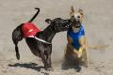  "dog fight" |  | 3.67
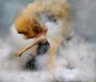  "wolken dek" | Geaccepteerd / Finalist | 4.00
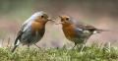  "wormpje geven" | Geaccepteerd / Finalist | 4.33

B - Open monochrome
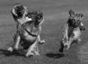  "afghanen race" | Geaccepteerd / Finalist | 4.00
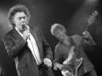  "Verminnen" |  | 2.67
"achterbuurt" | Geaccepteerd / Finalist | 4.00
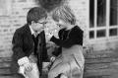  "Vithal&Zytha" | Geaccepteerd / Finalist | 4.00

C - Laugh, smile, good mood, parties, color or monochrome,
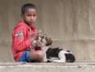  "honden liefde" |  | 2.67
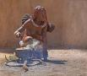  "potje roeren" |  | 2.67
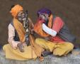  "smoking pipe" |  | 2.67
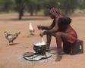  "koken op straat" |  | 2.67

D - Travel, color or monochrome, see FIAP January 2015
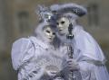  "venetie" |  | 3.67
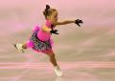  "schattige uitvoering" |  | 2.33
"een tatoe" |  | 1.67
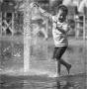  "water dansen" |  | 2.00

